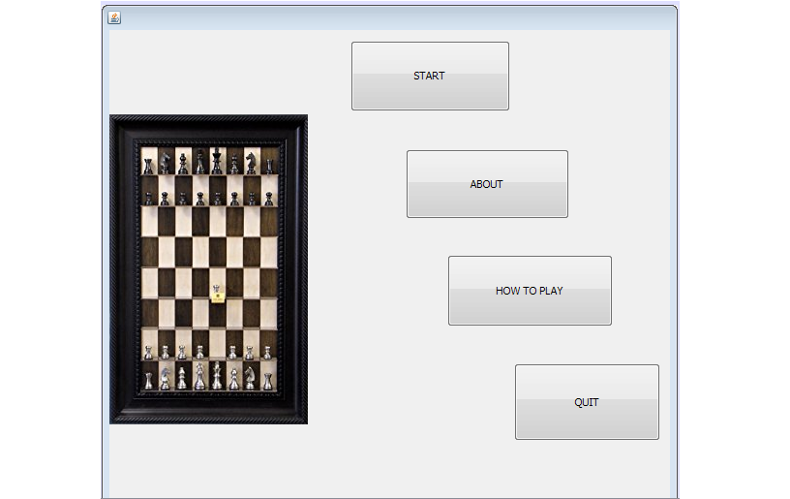  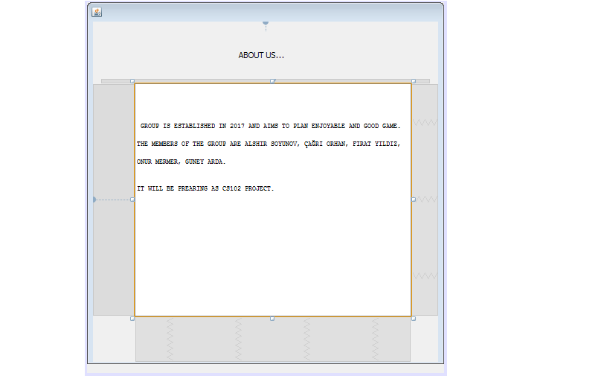  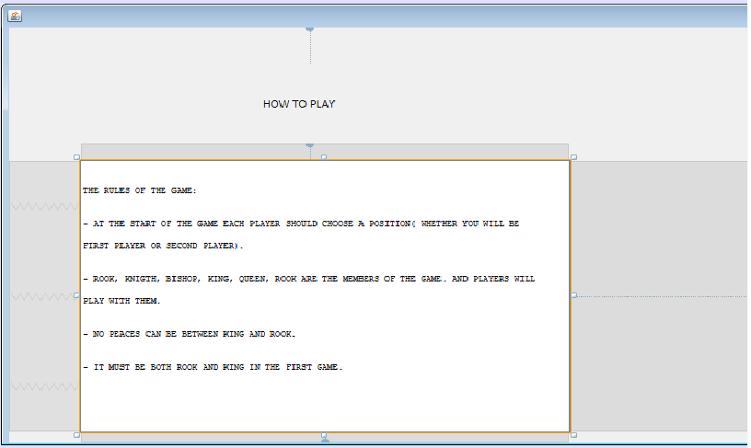  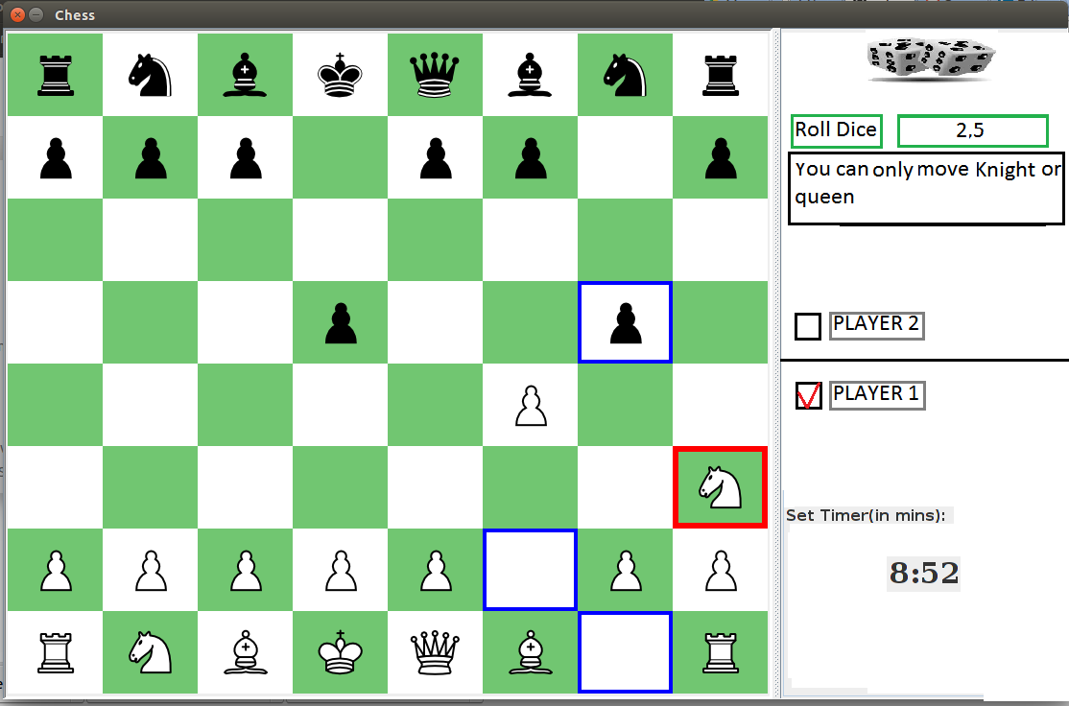  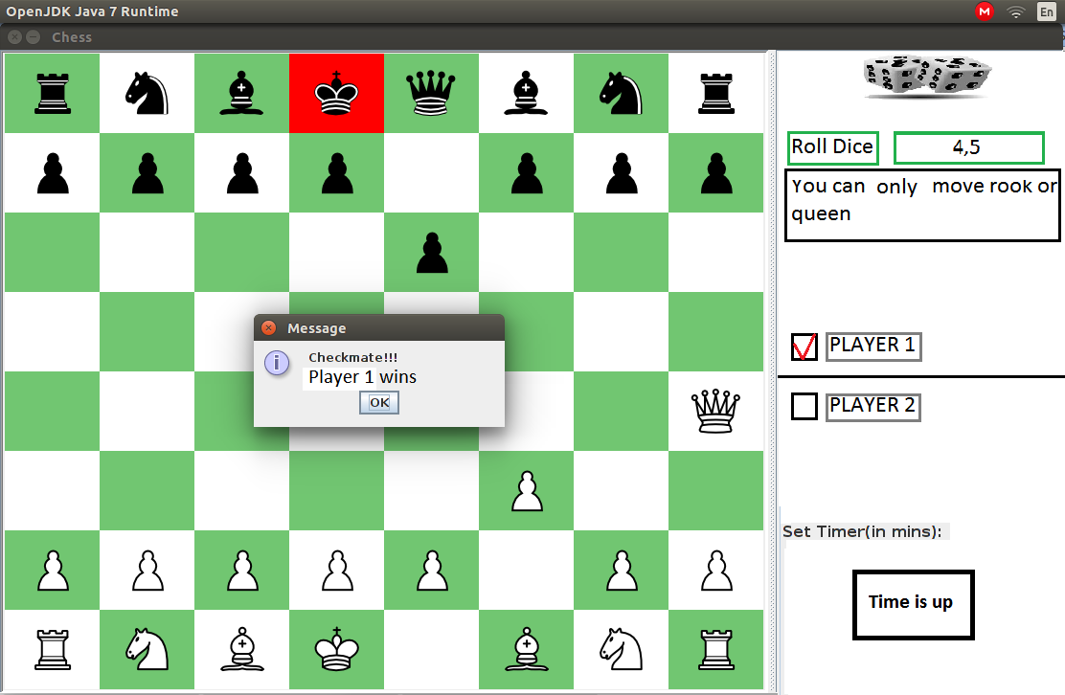  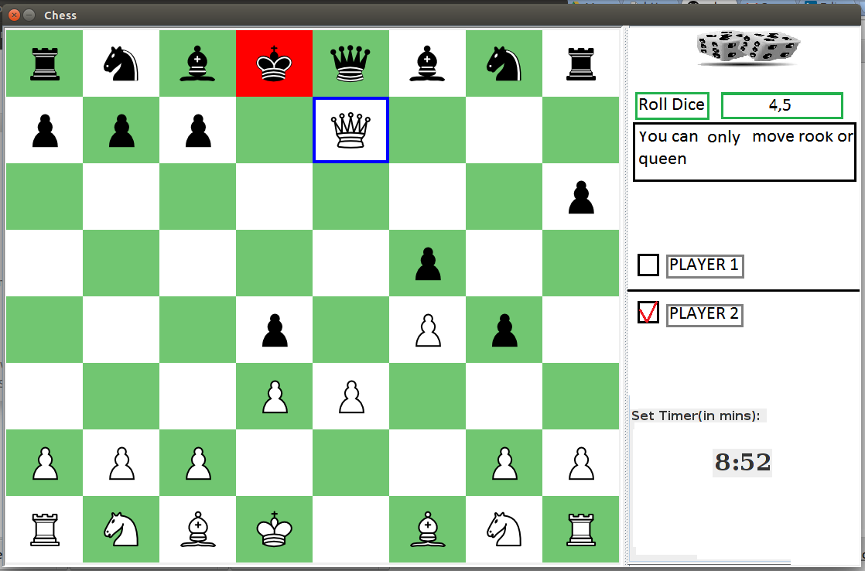  CS102 | Spring 2012/2013 |  |  | Project  Group | 1A
Instructor: | Instructors Name |  |  | Project  Group | 1A
Assistant: | Assistant's Name |  |  | Project  Group | 1A
Criteria |  | TA/Grader | Instructor
Presentation
Overall

~Dice Chess~
Nigth Watchers

Çağrı Orhan Fırat Yıldız Alshir Soyunjov Onur Mermer Güney Arda Doğan

Basic Interface Design Report
(Version 01)
17 November 2017

Introduction
In this report we will specify the rules of the “Dice Chess”, how to play it and how our game looks. Our general UI, Game rules and differences between dice chess and standard chess will all be covered here.

Details
[] [][]

Rules of Dice Chess
The rules of dice chess are as follows: The generic chess rules apply in dice chess. However what changes is what pieces a player can move. Each player starts their turns with a dice roll of two dice. If they get one they can play a pawn. If they get two they can play a knight. Same rule applies as follows: three for bishop, four for rook, five for queen, and six for king. If the player rolls doubles they can play any legal move they wish. You consider your moves for both the pieces you end up getting to play due to the dice roll. Additionally when a player has no legal move with either of the pieces indicated by the dice, they lose that turn. If the player has a legal move they cannot skip their turn. [1]
However there are two special moves that can be done in chess that can come across as unclear and as such they will be explained here. If castling is legal in the limitations of normal chess rules a player can castle if they have rolled four, six or doubles. Also, when legal within the chess rules, an en passant capture of a pawn is only possible if the player rolls a one or doubles immediately after their opponent moves their pawn double squares giving the player the opportunity for an en passant capture.[1]
Lastly in positions such as a check, a checkmate or a draw the rules are as follows: The game can end by either a checkmate or by the king getting captured except for the unlikely event of a draw. The king can be captured if the player in check cannot capture the checking piece and the checking player’s rolls the needed number to capture the king. In the case of a check, if the checked player does not roll a dice that lets them capture the checking piece or roll six to move their king out-of-the-way they lose their turn. The rules of check, checkmate and draw follows the standard rules of chess.[1]

The UI of Our Game
PAGE 1
That page is the page when the user opens the game first. It included four buttons which offers the user; play, see the information about the authors of this application, the rules of the game and quit game. The buttons “Start”, “ABOUT US”, “HOW TO PLAY” and “QUIT” exist in the label for this aim. After that page user may enter one of them.

PAGE 2
That page shows the user the information about the group and members. User may enter this page by click the “ABOUT US” button.
PAGE 3
That page shows the rules of the game. User may reach this page by clicking “HOW TO USE” button. This game is played by dice too so as to explain the rules briefly to the user, this page was added. The data in here is got from chesswarehouse.com.

A Sample Game
Player 1 rolled the dice and get 2 and 5. 2 refers to Knight and 5 refers to Queen. Player 1 can move either Knight or Queen. Player 1 chooses the Knight to move and possible destinations are indicated as bold cells.
This picture illustrates checkmate situation. The Player 1 rolls the dice and gets 4 and 5, which means Player 1 can move either Rook or Queen. Player 1 chooses to move the Queen which means Checkmate!
This picture shows the check situation. Player 2 rolled 4 and 5 which means he can move either rook or Queen. Since Player 2 is in danger, he must move the Queen to hinder the danger and thus, beats the Player 1’s Queen.

Summary & Conclusions

We are starting to finally see the glimpses of the end of our project and it looks promising. We finally have something to show for our researches and we hope this project to go smoothly. We will research even further and add even more features if need be. But for now we have created the vision of what is a standard and functioning dice chess game and we will not only make it happen but improve it if we can

- The Short Guide to Avoiding Plagiarism, David Davenport & Derya Davenport. URL: http://www.cs.bilkent.edu.tr/~david/plagiarism/ 2008. Last visited: 19/02/2012.
- Reference books and journals by providing sufficient information about the source so that someone can easily find it. Include: title, author, journal, publisher & publication date (page no’s too, if applicable.)
- Reference web-based resources by giving their title, author, URL and date (posted & visited.)

